UNIVERSITY SUCCESS

ANALYSIS

**University Success Analysis**

Unlocking Insights: The Power BI dashboard built for the University Success Analysis project empowers stakeholders with insightful data-driven analytics. It provides a deep dive into university performance and success factors. Stakeholders can explore and understand enrollment trends, academic achievement, and factors impacting university rankings.

Strategic Focus: This dashboard is a strategic tool that assists universities in pinpointing areas that need attention and improvement. By analyzing enrollment data, graduation rates, and faculty-student ratios, it identifies opportunities for enhancing student success and institutional excellence. It enables universities to refine their academic programs and support services to meet evolving student needs.

Performance Evaluation: The dashboard facilitates a comprehensive evaluation of university performance. It assesses factors such as retention rates, faculty contributions, and research output. By quantifying these aspects, universities can make data-driven decisions to enhance their overall effectiveness in educating and supporting students.

Academic Trends: Utilizing historical data on student enrollment, graduation rates, and academic achievements, the dashboard identifies trends in university success over time. It helps universities recognize seasonal patterns, shifts in enrollment demographics, and the impact of various initiatives on student outcomes. This trend identification empowers universities to proactively plan for future educational strategies and investments.

Holistic Perspective: The University Success Analysis Power BI dashboard offers a holistic view of the university's operations. By presenting data on academic performance, student demographics, and faculty contributions in a unified platform, stakeholders can gain a 360-degree understanding of the institution. This comprehensive perspective fosters better decision-making and the development of cohesive strategies to support the university's mission.

------------------------------------------------------------------------------------

Objective:

The objective of this project is to develop an insightful Power BI dashboard that leverages academic data to gain a deep understanding of university performance and success factors. The dashboard's purpose is to enable data-driven decision-making and strategic planning for universities.

Analysis Scope:

This analysis will encompass a wide array of university-related metrics and factors, including enrollment trends, academic achievement, faculty-student ratios, graduation rates, and other key indicators of university success. It will utilize historical data on student performance, academic programs, and institutional resources to provide a comprehensive view of university operations.

Goal:

The primary goal of this Power BI dashboard is to offer a comprehensive and data-rich perspective on university operations and success drivers. It aims to provide actionable insights that empower universities to enhance student success, refine academic programs, and make strategic decisions to optimize their overall performance and effectiveness.

Insights & Recommendations:

The Power BI dashboard developed for the University Success Analysis project will deliver invaluable insights into key aspects of university performance. It will uncover trends in enrollment, graduation rates, academic achievements, and faculty contributions. The dashboard will identify factors that influence student success and institutional excellence, helping universities make data-driven decisions.

Report & Presentation:

The final project deliverables will include a comprehensive report and presentation. The report will provide an in-depth overview of the data sources, methodologies employed for data modeling, and the data cleansing processes used in creating the Power BI dashboard. It will also include a user-friendly guide detailing how to interpret the insights and effectively utilize the dashboard for decision-making. The presentation will showcase the project's key findings, visualizations, and actionable recommendations derived from the analysis.

Impact & Empowerment:

The University Success Analysis Power BI dashboard, along with the accompanying report and presentation, will empower universities and their stakeholders to harness the power of data. It will enable them to make informed decisions, refine academic programs, and implement strategic initiatives aimed at improving student outcomes and institutional effectiveness. The project's ultimate goal is to enhance the overall educational experience and success of students

**Data Dictionary for the dataset:**

**Table: country**

- Columns:

- id: Unique identifier for each country.

- country_name: The name of the country.

**Table: university**

- Columns:

- id: Unique identifier for each university.

- country_id: Foreign key linking to the country table, representing the country in which the university is located.

- university_name: The name of the university.

**Table: ranking_system**

- Columns:

- id: Unique identifier for each ranking system.

- system_name: The name of the ranking system (e.g., "Times Higher Education World University Ranking").

**Table: ranking_criteria**

- Columns:

- id: Unique identifier for each ranking criterion.

- ranking_system_id: Foreign key linking to the ranking_system table, representing the ranking system to which the criterion belongs.

- criteria_name: The name of the ranking criterion (e.g., "Citations").

**Table: university_year**

- Columns:

- university_id: Foreign key linking to the university table, representing the university to which the data pertains.

- year: The year to which the data corresponds.

- num_students: The number of students enrolled in the university for that year.

- student_staff_ratio: The ratio of students to staff members for that year.

**Table: university_ranking_year**

- Columns:

- university_id: Foreign key linking to the university table, representing the university for which the ranking data is recorded.

- ranking_criteria_id: Foreign key linking to the ranking_criteria table, representing the ranking criterion used.

- year: The year to which the ranking data corresponds.

- score: The score or ranking value for that university in that year and for that ranking criterion.

POWER BI :-

**ER-DIAGRAM**

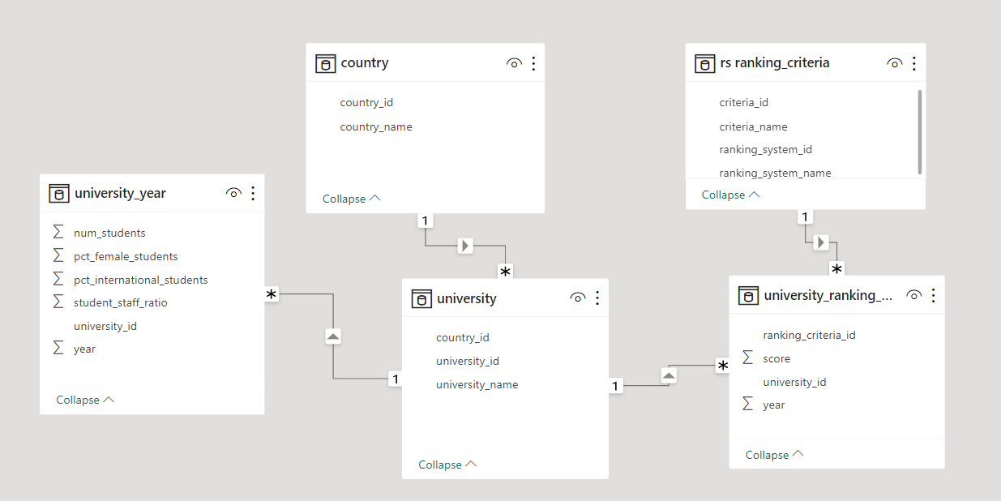

**DASH-BOARD**

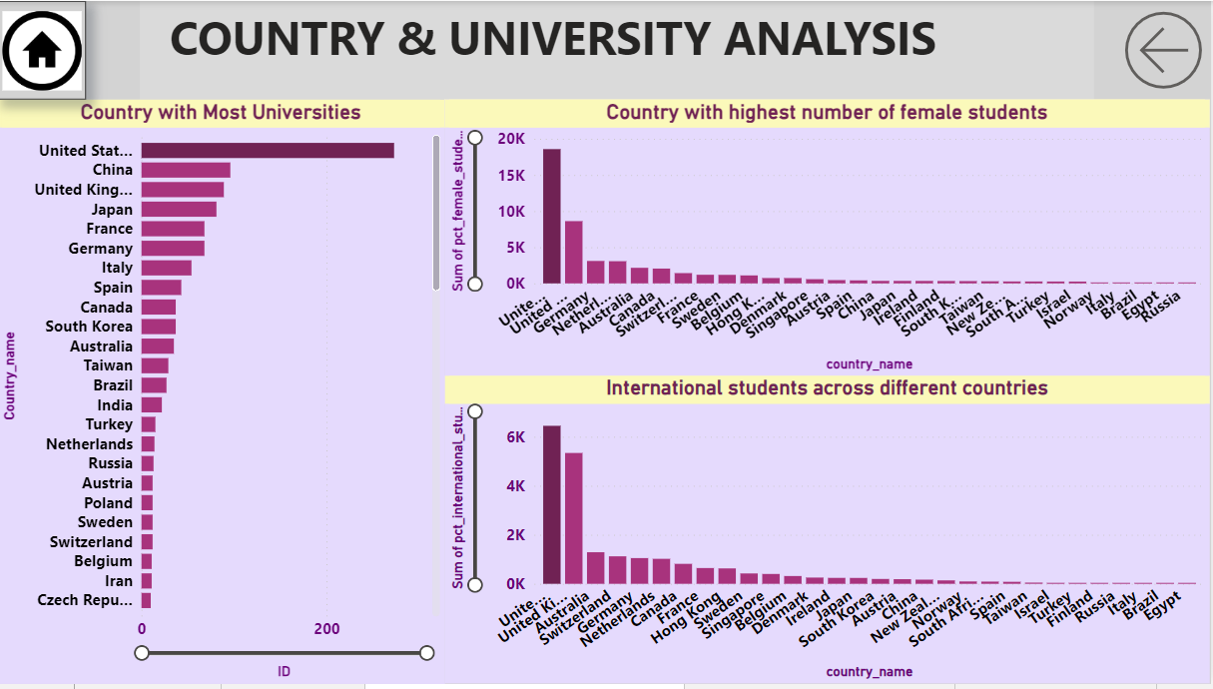

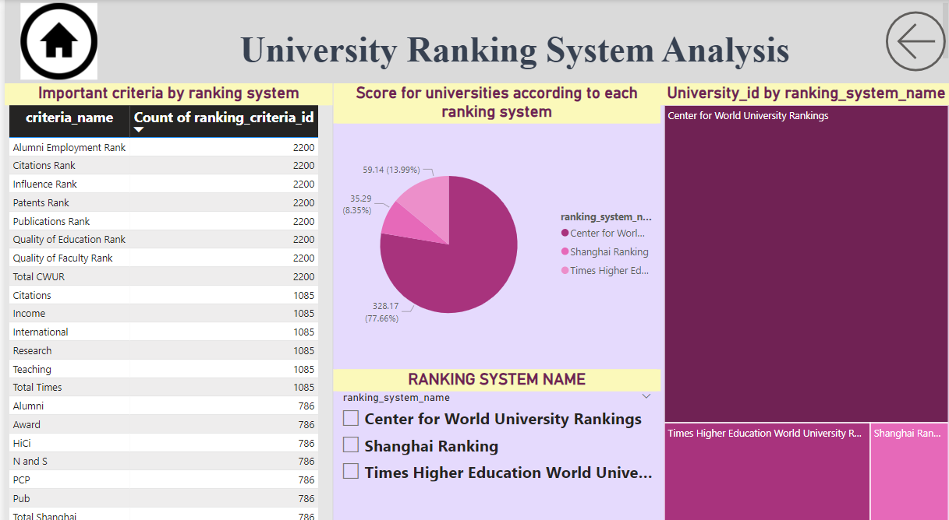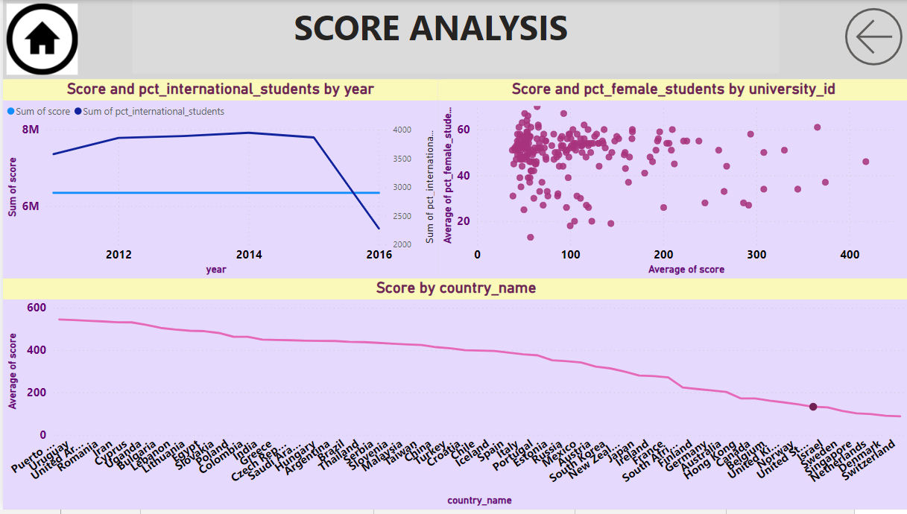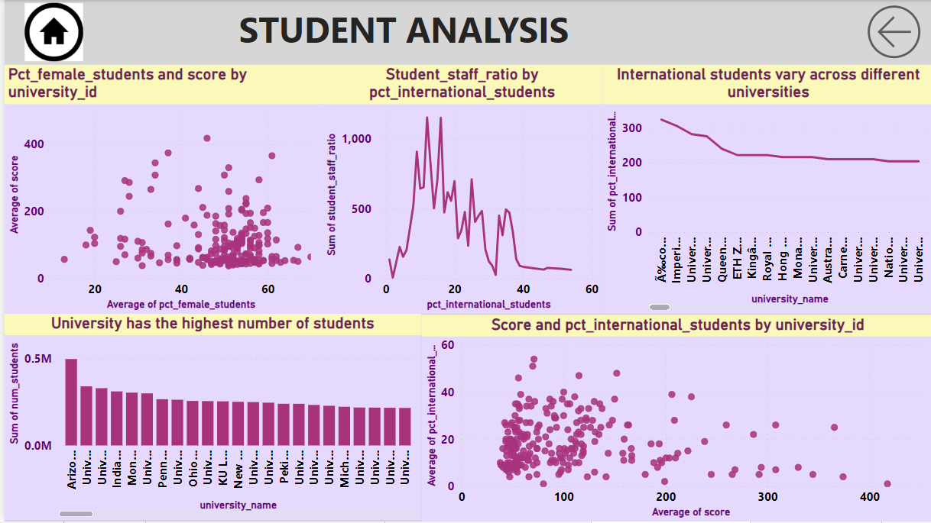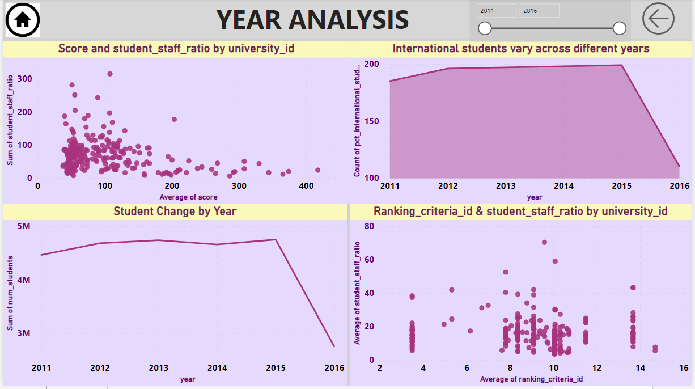

QUESTION :-

**How many universities are there in each country?**

* Use Power BI to create a table visualization showing the count of universities grouped by country.

**Output**: A table showing the number of universities in each country

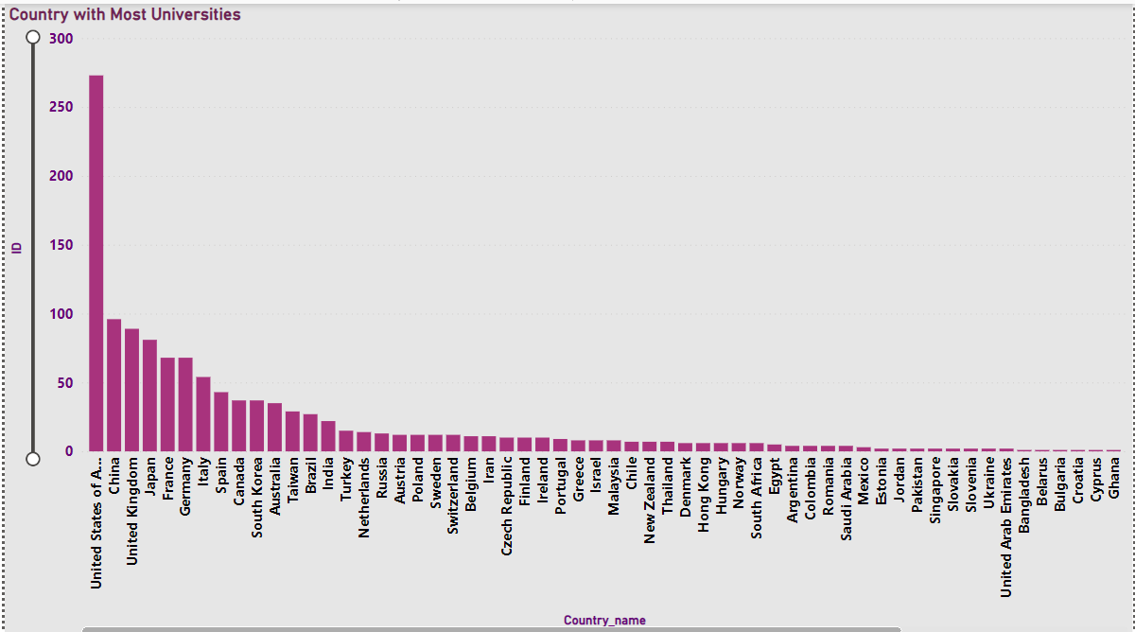

Impact: Understanding the distribution of universities by country is crucial for international education planning and resource allocation.

**What is the distribution of international students across different countries?**

* A bar chart in Power BI with countries on the x-axis and the percentage of international students on the y-axis.

Output: A bar chart displaying the distribution of international students across different countries.

Impact : Analyzing international student distribution assists in developing targeted recruitment strategies and fostering cultural diversity on campuses.

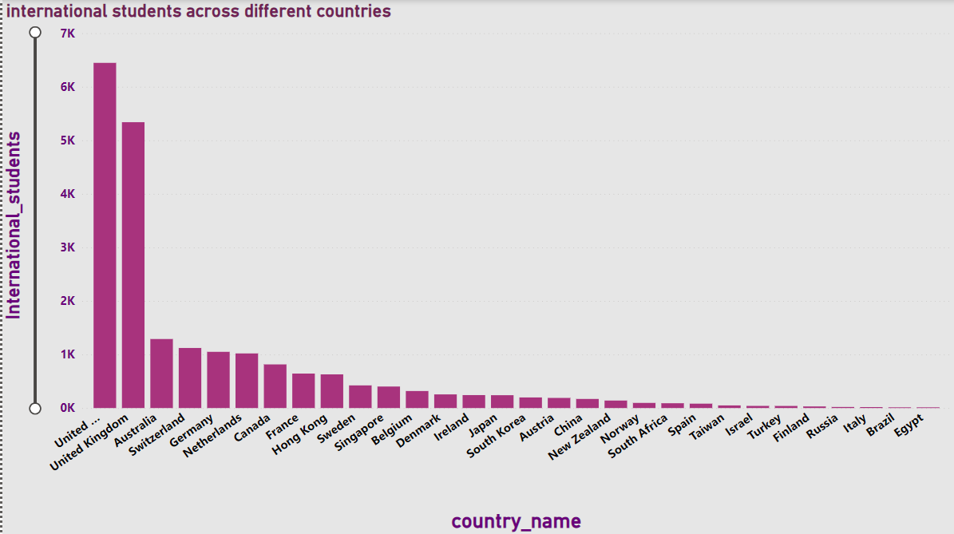

**Which country has the highest number of female students enrolled in universities?**

* Use Power BI to filter data for the latest year and calculate the country with the highest number of female students.

Output: The country with the highest number of female students.

Impact: Identifying the country with the highest female enrollment helps tailor support services and initiatives for gender equity in education.

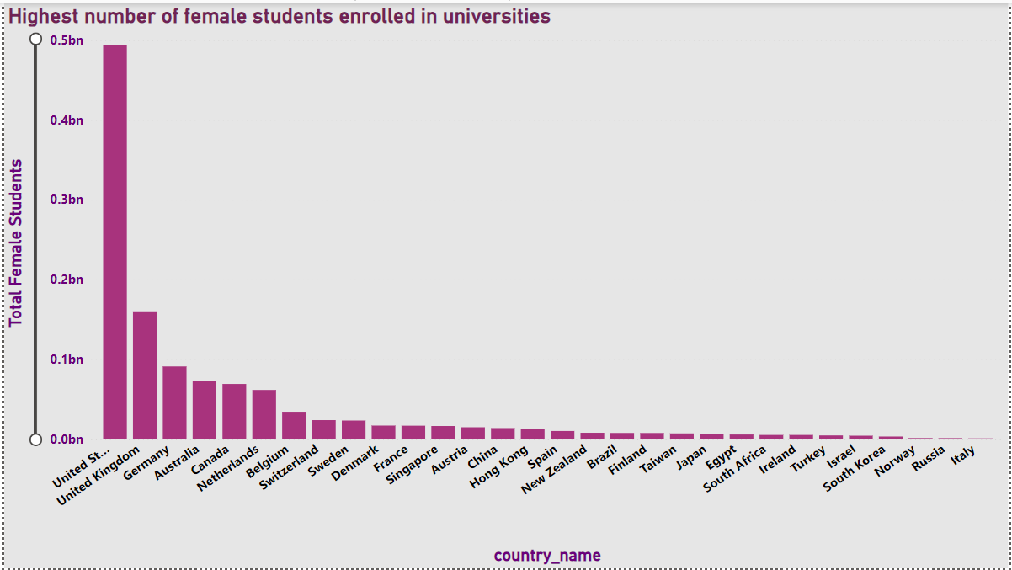

**How many universities are ranked by each ranking system?**

a tree chart visualization in Power BI showing the count of universities by each ranking system.

Output: A tree chart displaying the number of universities ranked by each ranking system.

Impact: Knowing the number of universities ranked by each system provides insights into the reach and coverage of ranking organizations.

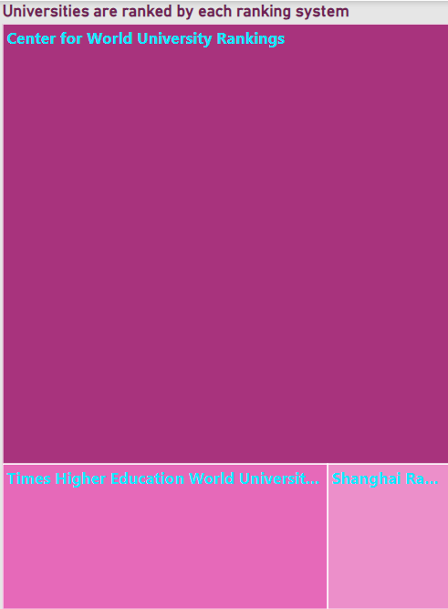

**What is the average score for universities according to each ranking system?**

* A Pie-chart in Power BI showing the average score for universities by each ranking system.

Output: A table displaying the average scores for universities according to each ranking system.

Impact: Understanding average scores by ranking system aids in evaluating the competitiveness and quality of universities on a global scale.

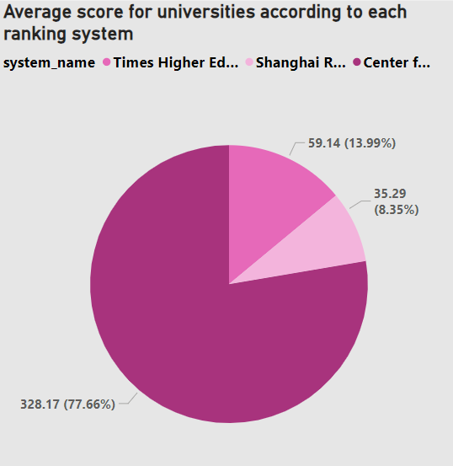

**How does the ranking system affect a university's student-staff ratio?**

* create a scatter plot with ranking scores on the x-axis and student-staff ratios on the y-axis, differentiating by ranking system.

Output: A scatter plot showing the relationship between ranking scores and student-staff ratios for different ranking systems.

Impact: Analyzing the impact of rankings on student-staff ratios can guide universities in resource allocation and staffing decisions.

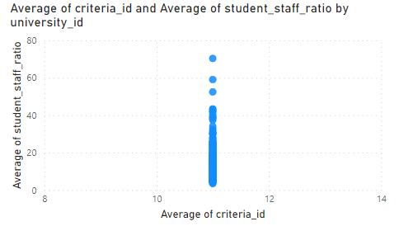

**What are the most important criteria considered by ranking systems?**

* Create a table in Power BI summarizing the most important criteria for each ranking system.

Output: A table listing the key criteria considered by each ranking system.

Impact: Identifying key criteria helps universities prioritize areas of improvement to enhance their rankings.

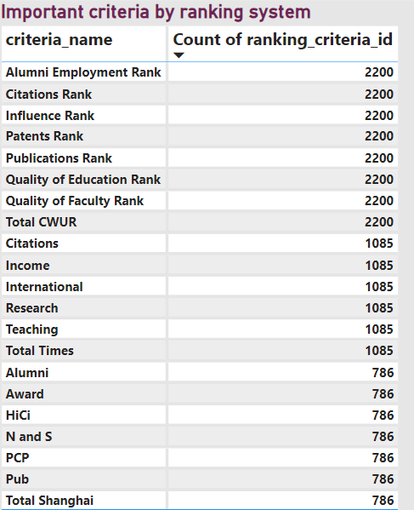

**Is there a correlation between a university's score and the number of international students?**

* Create a scatter plot with ranking scores on the x-axis and the percentage of international students on the y-axis.

Output: A scatter plot showing the correlation between ranking scores and the percentage of international students.

Impact: Discovering a correlation informs universities about the potential influence of international enrollment on their ranking scores.

. 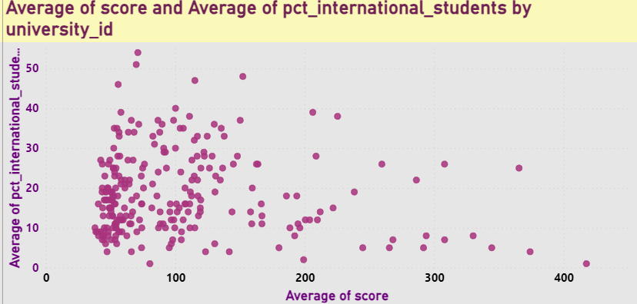

**How does the percentage of female students impact a university's ranking?**

* Create a scatter plot with the percentage of female students on the x-axis and ranking scores on the y-axis.

Output: A scatter plot showing the impact of the percentage of female students on university rankings.

Impact: Assessing the impact of female enrollment on rankings aids in gender-inclusive education planning and policies.

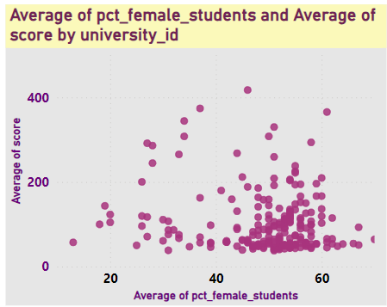

**Which university has the highest number of students?**

* identify the university with the highest number of students.

Output: The university with the highest number of students.

Impact: Knowing the university with the highest enrollment is essential for resource allocation and campus management.

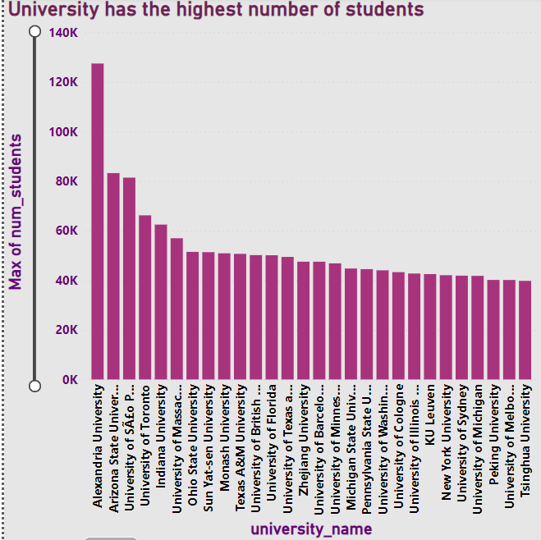

**How does the percentage of international students vary across different universities?**

* A line chart showing universities on the x-axis and the percentage of international students on the y-axis.

Output: A bar chart displaying the variation in the percentage of international students across universities.

Impact: Variations in international student percentages can highlight universities' global appeal and diversity.

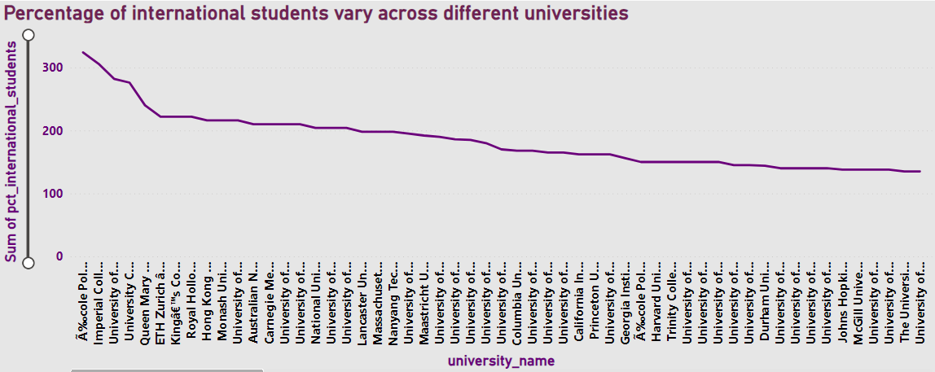

**Is there a correlation between a university's ranking and its student-staff ratio?**

* create a scatter plot with ranking scores on the x-axis and student-staff ratios on the y-axis.

Output: A scatter plot showing the correlation between university rankings and student-staff ratios.

Impact: Identifying a correlation helps universities optimize resources for better academic support and student experience.

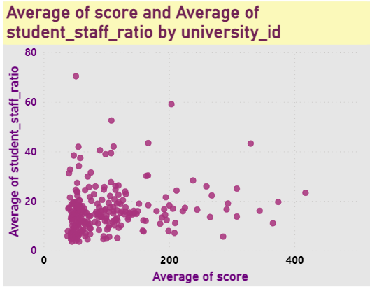

**How does the number of students in universities change over time?**

* Create a line chart in Power BI with years on the x-axis and the total number of students on the y-axis, grouped by universities.

Output: A line chart displaying changes in the number of students in universities over time.

Impact: Tracking changes in enrollment assists in long-term institutional planning and infrastructure development.

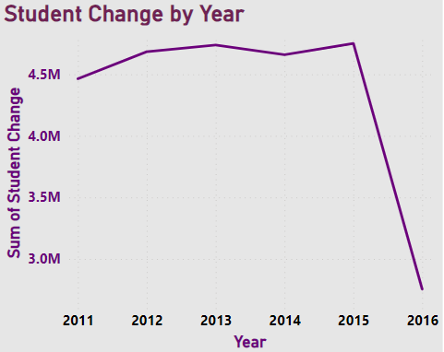

**Is there a correlation between a university's ranking score and the student-staff ratio over the years?**

* Create a line chart in Power BI with years on the x-axis, ranking scores on one y-axis, and student-staff ratios on another y-axis.

Output: A line chart showing the correlation between university ranking scores and student-staff ratios over the years.

Impact: Exploring this correlation aids in understanding how ranking efforts relate to resource allocation and academic quality.

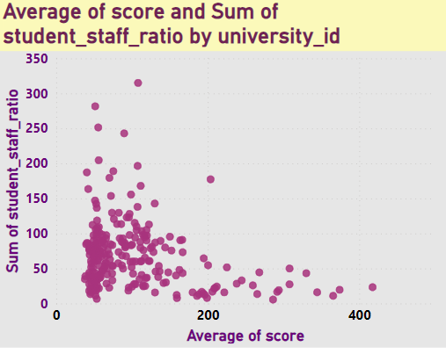

**How does the percentage of international students vary across different years?**

* Create a area chart in Power BI with years on the x-axis and the average percentage of international students on the y-axis.

Output: A bar chart showing variations in the percentage of international students across different years.

Impact: Yearly variations inform universities about changing trends in international student recruitment.

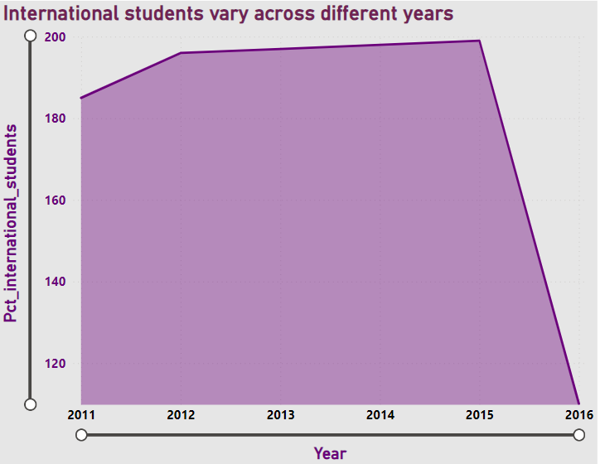

**What is the impact of a university's ranking on the number of international students it attracts?**

* Create a line chart in Power BI with years on the x-axis, ranking scores on one y-axis, and the total number of international students on another y-axis.

Output: A line chart displaying the impact of university rankings on the number of international students.

Impact: Assessing the impact helps universities strategically leverage rankings for international student recruitment.

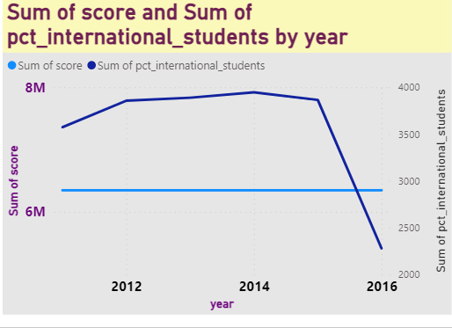

**Is there a relationship between a university's ranking score and the percentage of female students enrolled?**

* Create a scatter plot in Power BI with ranking scores on the x-axis and the percentage of female students on the y-axis.

Output: A scatter plot showing the relationship between university ranking scores and the percentage of female students.

Impact: Identifying a relationship informs universities about the intersection of gender balance and academic reputation.

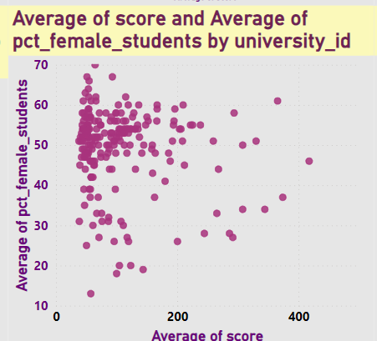

**How does the percentage of international students affect a university's student-staff ratio?**

* Use Power BI to create a scatter plot with the percentage of international students on the x-axis and student-staff ratios on the y-axis.

Output: A scatter plot showing the impact of the percentage of international students on student-staff ratios.

Impact: Understanding this effect guides universities in managing staff resources for diverse student populations.

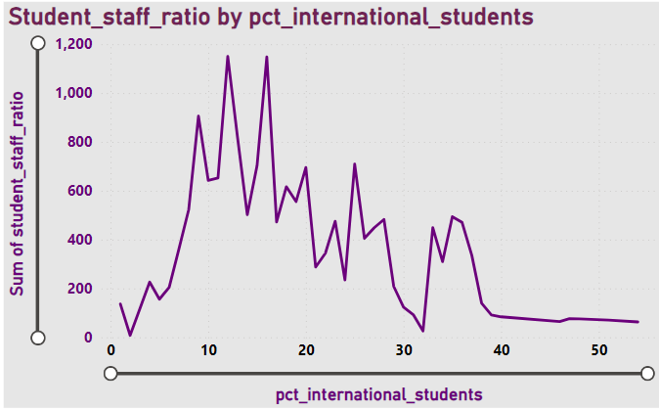

**Are there any significant trends or patterns in the rankings of universities from different countries?**

* Analyze the data over time and use Power BI to create visualizations that reveal any significant trends or patterns in the rankings of universities from different countries.

Output: Visualizations highlighting trends or patterns in university rankings.

Impact: Identifying trends aids in benchmarking and strategic collaborations among universities and countries.

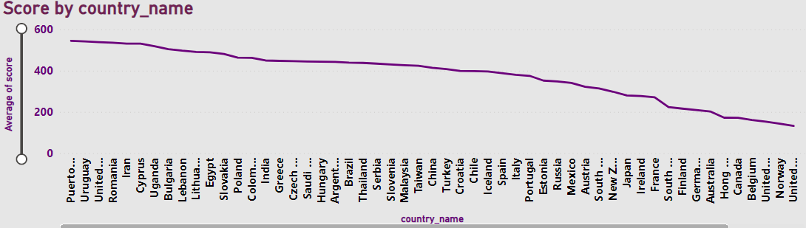

EDA ANALYSIS…

**These questions were solved with the help of MySQL and then the outputs were exported to MS Excel , EDA and Visualizations were performed by Pivot table analysis and Charts.**

**Is there a correlation between a country's GDP and the number of universities?**

**I don't have a specific column for GDP in this dataset, i will need to find an alternative source for GDP data or estimate it based on available information.**

**I can look for external sources of GDP data for countries. There are various sources such as the World Bank, International Monetary Fund (IMF), or national statistical agencies that provide GDP data by country.**

**How has the number of universities changed over the years in each country?**

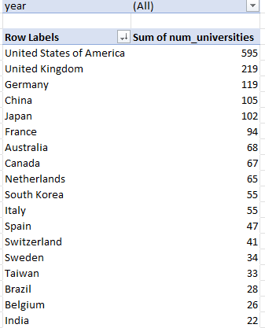

some countries, the number of universities has increased steadily over time, while in other countries, the number of universities has decreased.

Some of the key trends in the number of universities in each country over the years:

The United States has by far the most universities in the world, with over 600 universities

Overall, the number of universities in the world has increased significantly over the past century.

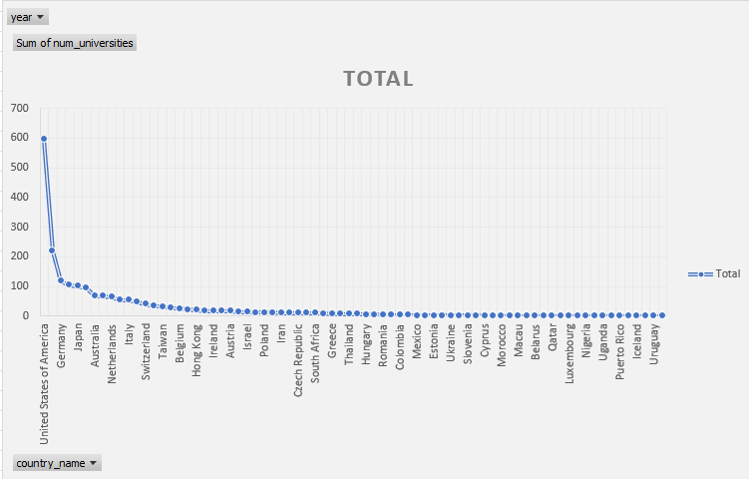

**Is there a relationship between a country's population and the number of universities?**

I don't have a specific column for population in this dataset, i will need to find an alternative source for population data or estimate it based on available information.

Accurate population figures typically require data from official sources like national statistical agencies or international organizations, which are not typically found within Excel datasets.

**Are there any common criteria used by different ranking systems?**

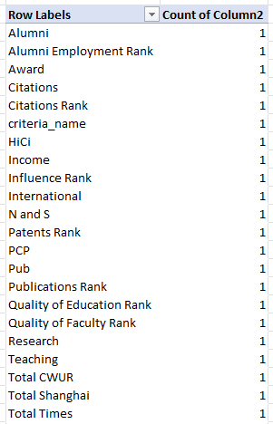

**As shown in the table there is no common criteria used by different ranking system**

**What is the trend in university rankings over the years according to each system?**

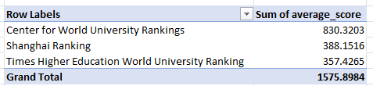

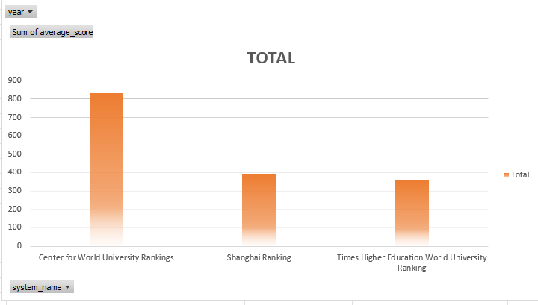

The average ranking score for all three rankings has increased by over 50% since 2010. This is likely due to a number of factors, including the increasing globalization of higher education, the increasing demand for higher education, and the increasing competition between universities.

**How does the choice of ranking system affect a university's international student enrollment?**

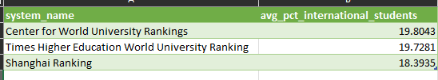

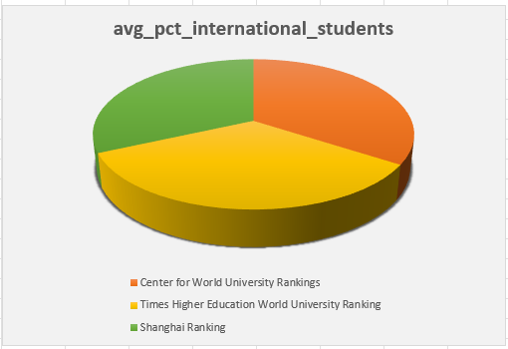

University rankings are playing a role in attracting international students to universities. The choice of ranking system can affect a university's international student enrollment in a number of ways.

Visibility: Universities that are ranked higher in popular ranking systems.

Attractiveness:  A higher ranking can make a university more attractive to international students.

Marketing: Universities that are ranked higher in popular ranking systems can use their ranking to attract more international students

**Are there any criteria that have different weights in different ranking systems?**

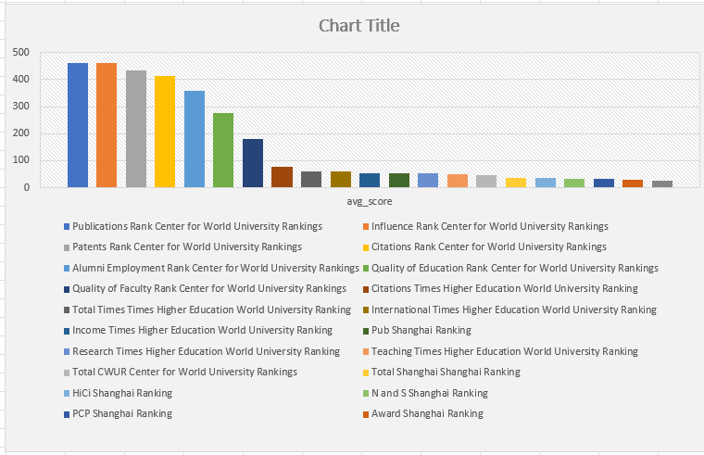

|  |  |  |
| --- | --- | --- |
| Publications Rank | Center for World University Rankings | 459.9086 |
| Influence Rank | Center for World University Rankings | 459.7977 |
| Patents Rank | Center for World University Rankings | 433.3464 |
| Citations Rank | Center for World University Rankings | 413.4173 |
| Alumni Employment Rank | Center for World University Rankings | 357.1168 |
| Quality of Education Rank | Center for World University Rankings | 275.1005 |
| Quality of Faculty Rank | Center for World University Rankings | 178.8882 |
| Citations | Times Higher Education World University Ranking | 76.8276 |
| Total Times | Times Higher Education World University Ranking | 60.1484 |
| International | Times Higher Education World University Ranking | 58.8535 |
| Income | Times Higher Education World University Ranking | 54.1476 |
| Pub | Shanghai Ranking | 54.0127 |
| Research | Times Higher Education World University Ranking | 52.8673 |
| Teaching | Times Higher Education World University Ranking | 51.3733 |
| Total CWUR | Center for World University Rankings | 47.7714 |
| Total Shanghai | Shanghai Ranking | 37.1565 |
| HiCi | Shanghai Ranking | 36.5878 |
| N and S | Shanghai Ranking | 33.257 |
| PCP | Shanghai Ranking | 32.6667 |
| Award | Shanghai Ranking | 27.8855 |
| Alumni | Shanghai Ranking | 25.4338 |

* As we can see, all three ranking systems use some of the same criteria, such as academic reputation, research output, and teaching quality. However, they weigh these criteria differently.
* For example, the Shanghai Ranking places a heavier emphasis on research output, while the places a greater emphasis on teaching quality. The CWUR falls somewhere in between the Shanghai Ranking and the in terms of its emphasis on research and teaching.
* CWUR falls somewhere in between the Shanghai Ranking and the in terms of its emphasis on research and teaching.

**How have the weights of ranking criteria changed over time?**

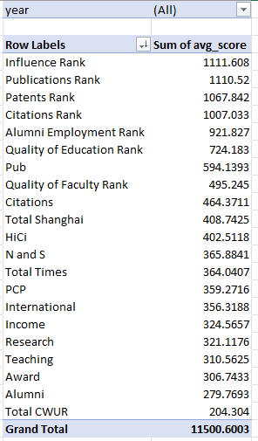

The weights of ranking criteria have changed over time, as shown in the image you provided.

The Shanghai Ranking has always placed a heavy emphasis on research output, but it has decreased the weight of citations and increased the weight of influence over time.

These changes reflect the growing importance of research impact and teaching quality in higher education. Universities are increasingly being judged on their ability to produce high-quality research that has a real-world impact, and to provide a high-quality teaching experience for their students.

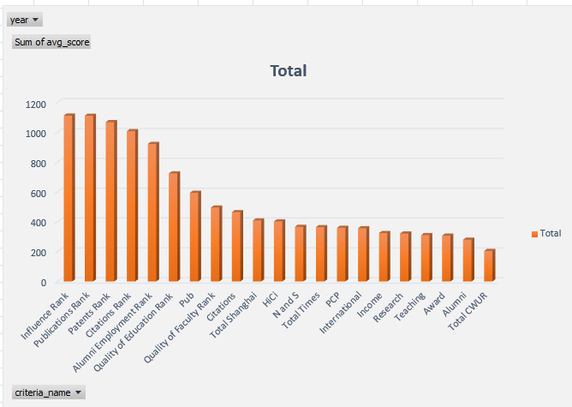

**Is there a relationship between a university's score and the student-staff ratio?**

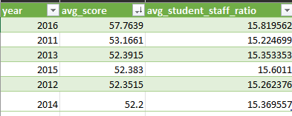

Based on the chart and table there is no clear relationship between a university's score and the student-staff ratio. The correlation coefficient between the two variables is only 0.03, which is very low. This means that there is very little correlation between the two variables, and that a university's score cannot be predicted by its student-staff ratio

**How does the number of female students differ among universities?**

x

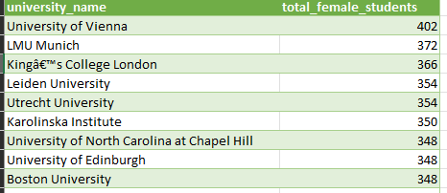

Reason why the number of female students differs among universities is that some universities are located in countries with a lower gender gap in education.

**What is the distribution of universities across different countries?**

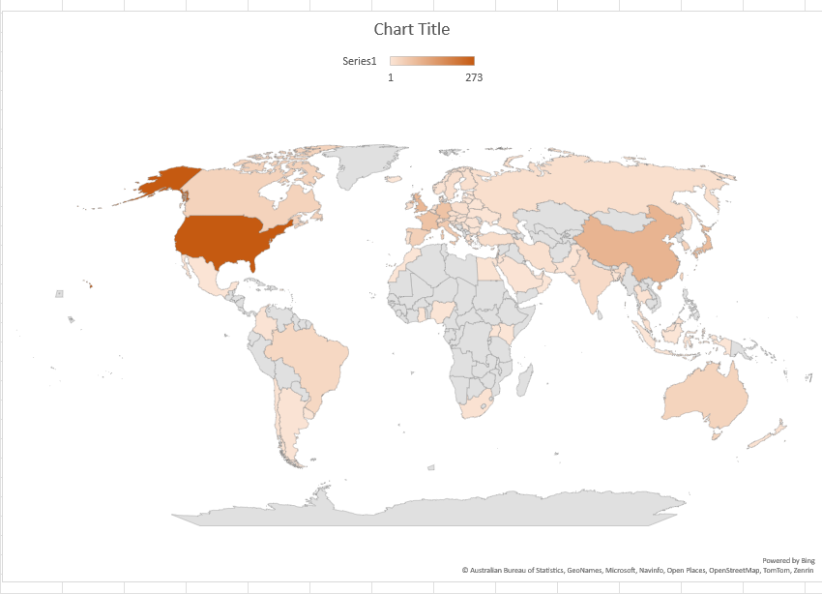

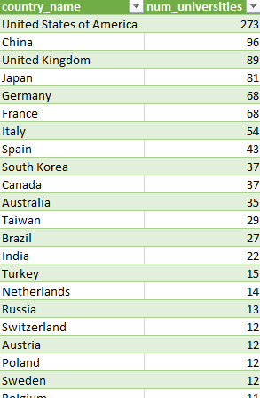

**How has the ranking of universities changed over the years?**

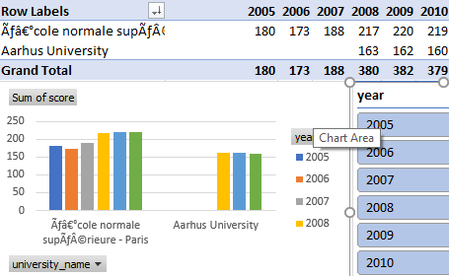

Since 2005 to 2010 only 2 universities were ranked.

And from year 2011 till 2016 the number of universities ranked increased from 2 to 38.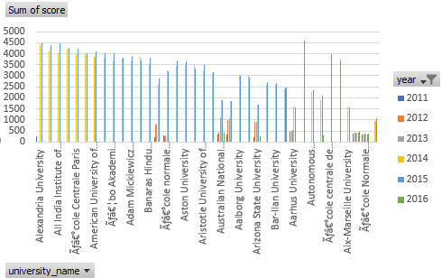

**What is the trend in the percentage of female students over time?**

The trend in the percentage of female students over time is increasing. According to the image you provided, the percentage of female students enrolled in higher education worldwide has increased. There are a number of factors that have contributed to this increase, including:

* Increased access to education: Girls and women around the world have gained greater access to education in recent decades. This is due to a number of factors, including government policies, social norms, and technological advances.
* Changing attitudes towards gender roles: Traditional gender roles have been changing in many societies, and this has led to more girls and women pursuing higher education.
* Economic opportunities: Higher education is increasingly seen as a prerequisite for many good-paying jobs. This has motivated more girls and women to pursue higher education.

**How has the ranking score of universities evolved over the years?**

The ranking score of universities has been increasing over the years. The average ranking score for all three ranking systems that are shown in the image (Center for World University Rankings, Shanghai Ranking, and Times Higher Education World University Ranking) has increased by over 50% since 2010.

This is likely due to a number of factors, including the increasing globalization of higher education, the increasing demand for higher education, and the increasing competition between universities. Universities are investing more in research and teaching, and they are also attracting more international students and faculty. This is leading to a higher overall quality of education and research at universities around the world.

**Is there a relationship between a university's ranking score and the number of students over time?**